

***ACADEMY 2023-24***

***APPLICATION PACK***

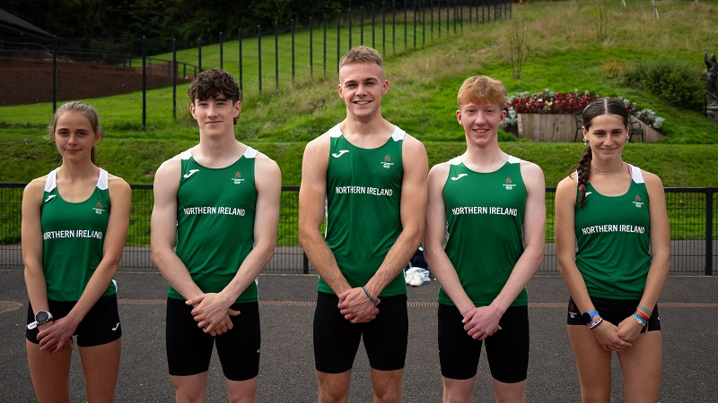

***NURTURING JUNIOR TALENT***

***ASPIRING TO SENIOR SUCCESS***

**VISION**

In September 2014 Athletics Northern Ireland launched the Youth Academy to support Northern Ireland’s talented young athletes and their coaches.

“***We believe physical & technical preparation and a performance mindset are critical for athlete development and we must create a challenging, supportive, open and professional environment where athletes and coaches can fulfil their potential.***”

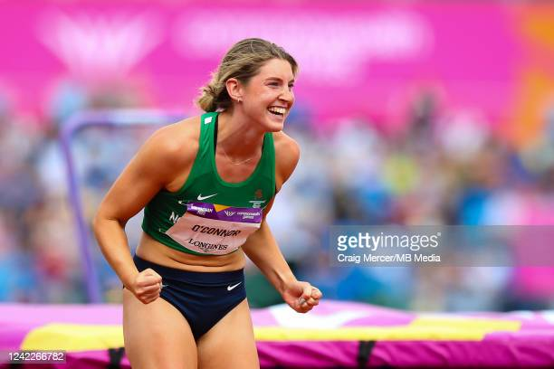Athletics Northern Ireland's Academies aim to identify and develop talented junior athletes and raise their potential for senior success. We are focused on improving physical qualities, sporting knowledge, psychological skills and performance behaviours in young athletes whilst educating parents and coaches on what it takes to perform consistently on the international stage as seniors. In doing so we believe Northern Ireland will develop a pipeline of junior athletes who will become successful seniors representing Northern Ireland at the Commonwealth Games and Great Britain or Ireland at major championships.



**SUCCESSES**

Since establishing the Academy in 2014 supported Athletes have achieved Commonwealth Youth Games Medals, European Junior Medals & World Para Medals & made breakthroughs to compete at European Team Championships, Senior Commonwealth Games, European & World Indoors.

European Cross-Country Championships were held in Turin in December 2022 with 4 Northern Ireland athletes selected to represent Ireland on the U20 team. Nick Griggs and Callum Morgan brought home silver medals in the team event with Nick also finishing in silver medal position in the individual event.

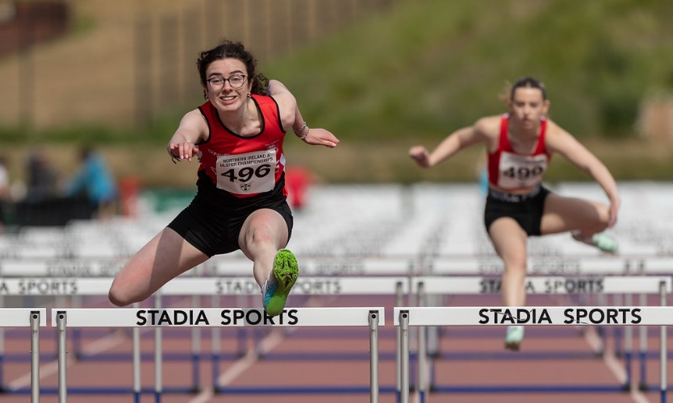The 2023 summer season saw 4 major championship opportunities for junior and U23 athletes. The delayed Commonwealth Youth Games took place in Trinidad with Jamie Moffatt (100m), Toby Thompson (200m), Lucy Foster (1500m), Frank Buchanan (1500m) and Anna Gardiner (3000m) representing Northern Ireland on the international stage. Veronica O’Neill (100mh) and Oisin McGloin (3000m) represented Ireland at the European Youth Olympic Festival in Maribor, Slovenia. At the European U20 Championships in Jerusalem Nick Griggs won a silver medal in the 1500m with Lughaidh Mallon also competing in the 1500m. Callum Baird (400m), Callum Morgan (5000m) and Oliver Swinney (100m) represented Ireland at the European U23 Championships in Espoo, Finland.

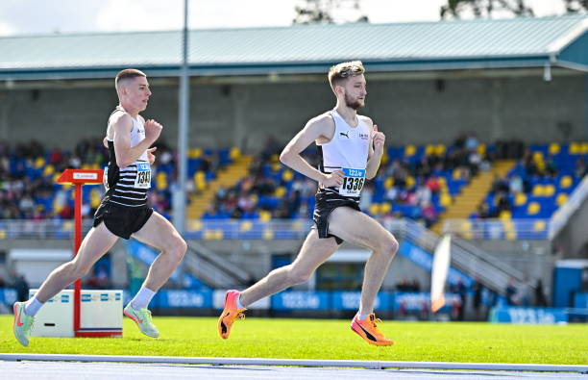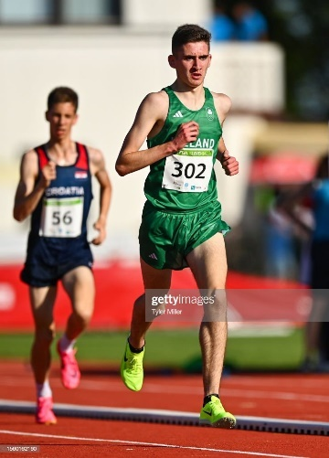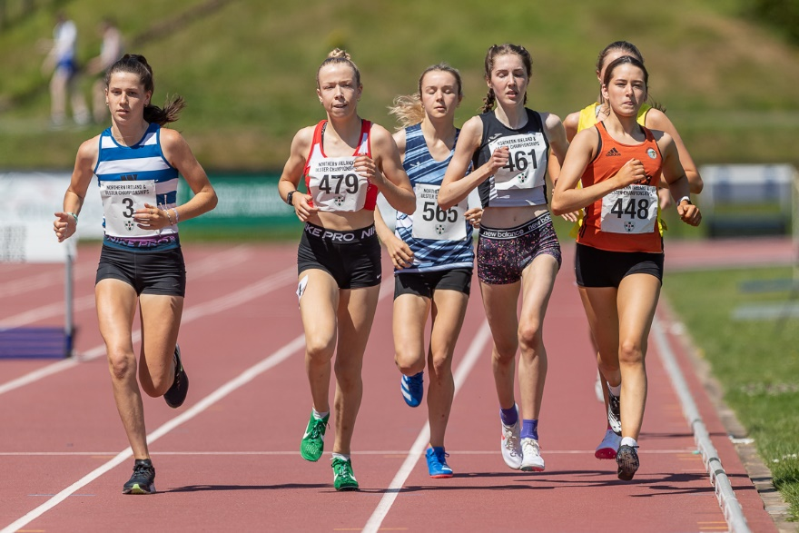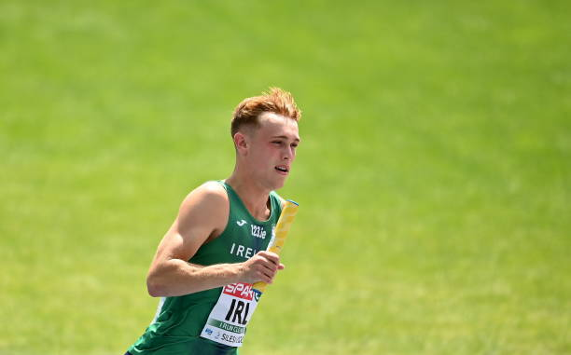

**ACADEMY STRUCTURE & SUPPORT FOR 2023-24**

In September 2023 athletes aged under 22 years old will be eligible to apply to either:

**Youth Academy** (for NI eligible athletes aged between 15-21 years old)

**Speed Power Academy** (NI *and Ulster* Eligible Athletes aged 14-18 years old.) This will suit athletes aspiring to future Youth Academy selection.

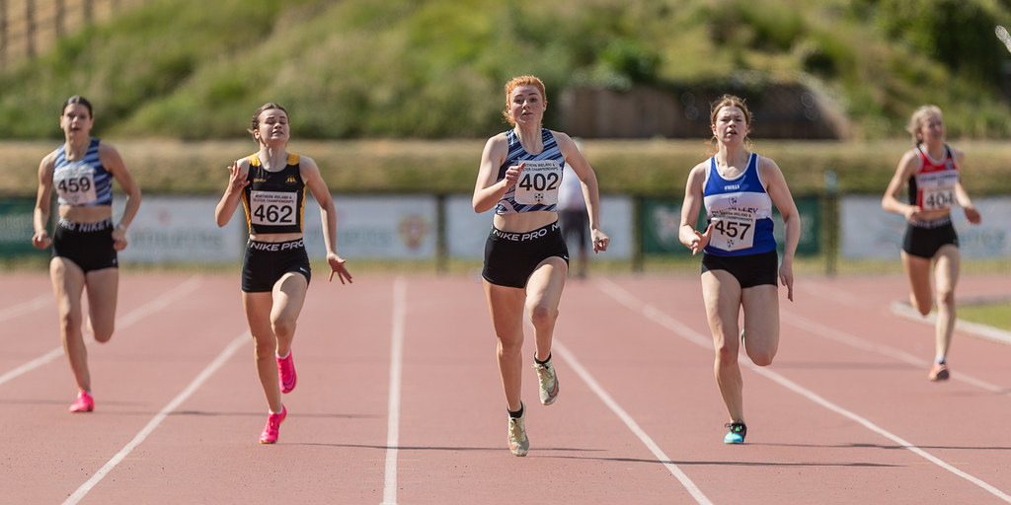

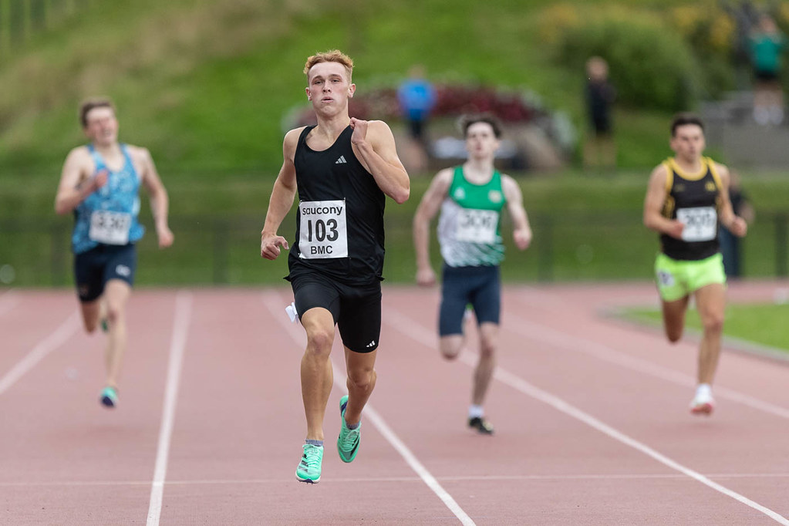



|  |  |
| --- | --- |
| * **Weekly Speed Development** | * **Weekly Speed Development** |
| * **Weekly Strength and Conditioning** | * **Weekly Strength and Conditioning** |
| * **Quarterly Strength Diagnostics and profiling** | * **Quarterly Strength Diagnostics** |
| * **Integrated Physiotherapy Clinics** | * **Movement Screening** |
| * **Athlete, Parent and Coach Education** * **Performance planning support for athletes and coaches** | * **Athlete, Parent and Coach Education** |
|  |  |
|  |  |

**YOUTH ACADEMY SERVICES**

The Athletics Northern Ireland Youth Academy has proven popular and successful and now has bases at Jordanstown and Coleraine delivering weekly physical preparation and athlete education sessions. Delivery will recommence at both bases in October 2023.

Youth Academy will offer the following support dependant on relevance to the athlete-coach pair applying:

* **A launch weekend on Sunday 29th October 2023** at Ulster University Jordanstown where athlete and coaches will attend for baseline assessments to assist with goal setting and planning for the upcoming year.
* **Two additional camps in January and April at Ulster University Jordanstown**
* **Weekly sessions** commencing on the week beginning 16th October 2023 focused on speed development, strength & conditioning and plyometrics
* **Bespoke Athlete and coach education** sessions focusing on nutrition, recovery, planning, mindset etc
* **Monthly / fortnightly physiotherapy clinics** with Academy physiotherapists Anna Lawther (Jordanstown) and Stephen Haslam (Coleraine) with some discretionary 1-1 physiotherapy support based on need.
* A handful of Youth Academy Athletes who are tracking toward major championships may be able to access increased planning support.

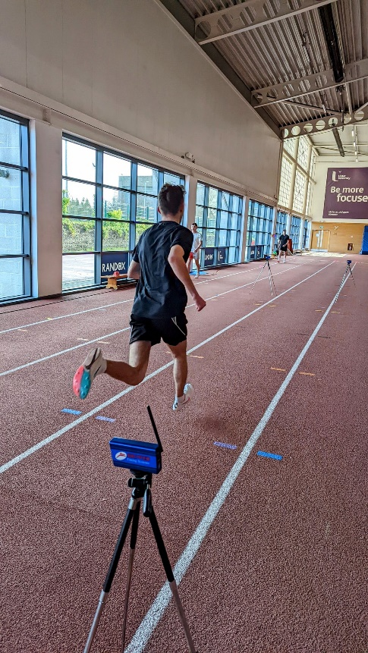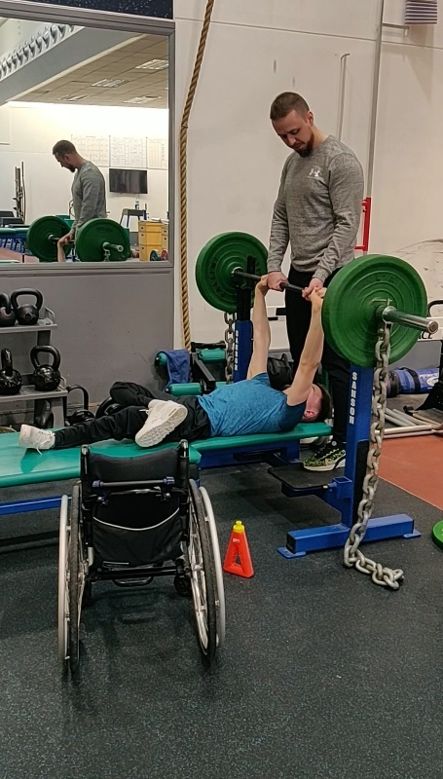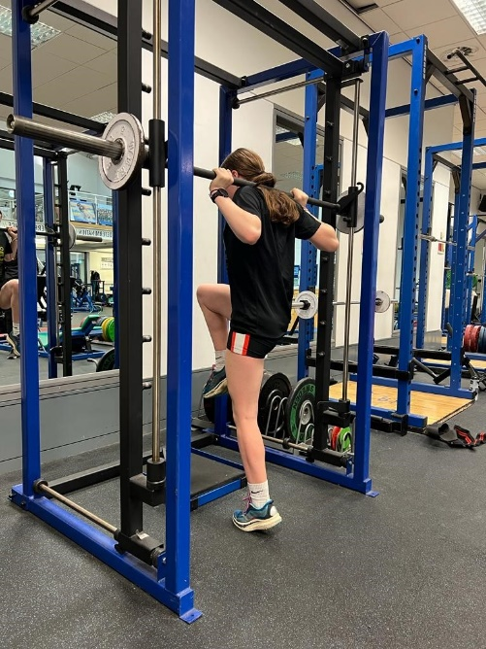

**SPEED -POWER ACADEMY**

The Speed - Power Academy, delivered at Ulster University Jordanstown and launched in 2018, was established to expose athletes aged 14-18 years old from all events (sprints, jumps, endurance and throws) and their coaches to the basic physical preparation concepts behind the Youth Academy. The aim is to help young athletes transition successfully to event group training and ideally, for those who are NI eligible - the Youth Academy.

***“This academy will help support athletes from the additional 3 counties of Ulster as well as those resident in NI. Athletes will be supported with weekly speed development and strength and conditionings sessions led by Athletics NI staff.”***

Support this year will include 3 half day camps at Ulster University Jordanstown in October, January and April with bespoke educational workshops. Monitoring via electronic timing and force plates for strength diagnostics will be ongoing throughout delivery with timely feedback to coaches.

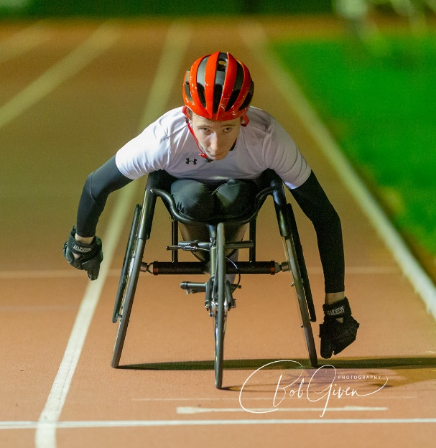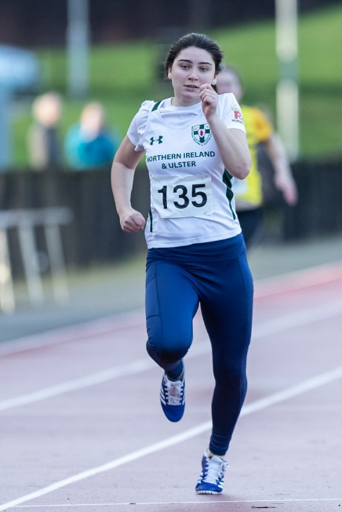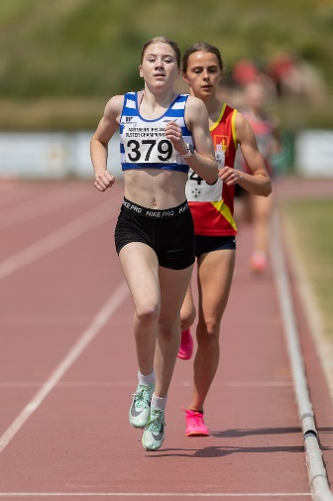

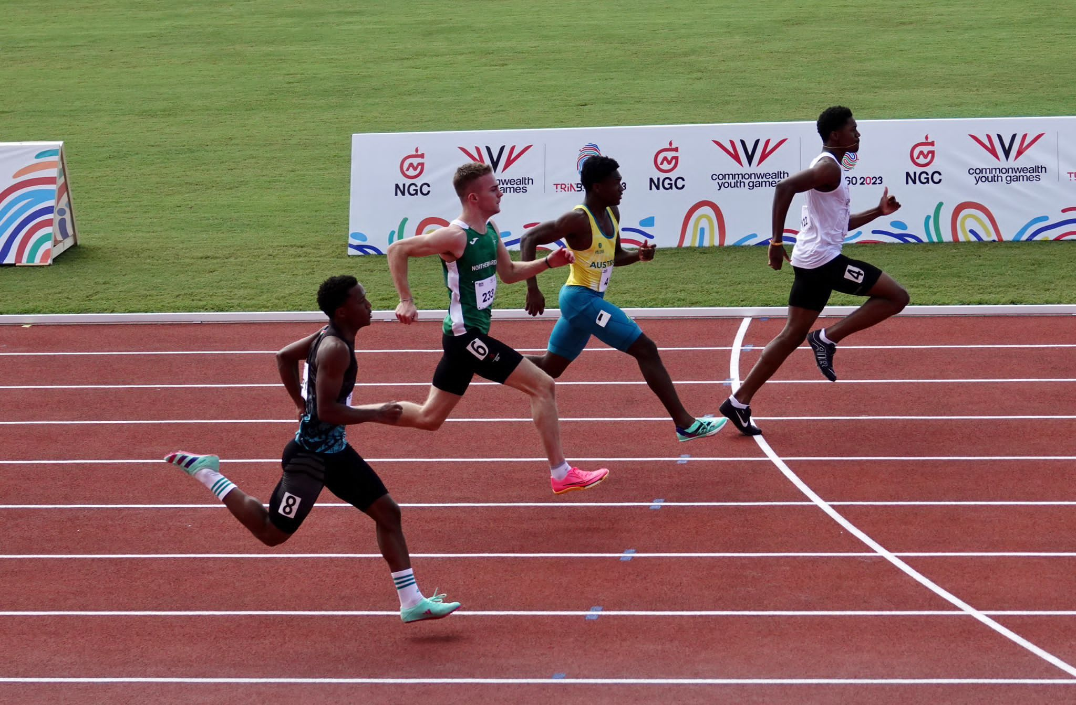

**ELIGIBILITY**

To be eligible for:

* **Youth Academy**… an athlete must be eligible for NI Commonwealth Games selection by fulfilling one of the below criteria
  + Being born in NI
  + Having at least 1 parent or grandparent born in NI
  + Having 3 years residence in NI.
* **Speed - Power Academy**… an athlete must be either NI eligible (as above) or Ulster eligible (from one of the additional 3 counties of Ulster.)

**RETENTION**

The Youth Academy is designed to deliver a 3-year curriculum. It is expected that for 2023-2024 there will be competitive applications from a number of new athletes and spaces are not guaranteed for athletes reapplying who have not shown upward progress. Occasional extensions are made for an athlete who has entered very young and would benefit from an additional year of support to assist with their first-year transition to university or work post 18. Where an athlete is clearly on a trajectory towards future Commonwealth Games and Youth Academy inclusion would help them to bridge the gap to the Athletics NI Commonwealth Potential Squad their time in the Academy may be extended beyond 3-4 years.

The Speed-Power Academy is designed to deliver a 2-year curriculum with the hope that NI eligible athletes may progress to Youth Academy. Those aiming to progress from Speed Power Academy to Youth Academy will still be assessed on performance standards and compared against all other applicants. Those showing progress in Speed Power Academy after year 1 are most likely to be retained for another year. After 2 years in the Speed Power Academy athletes who have not progressed to Youth Academy will still have new knowledge, skills and abilities to support them in working with their personal coach.

**WEEKLY DELIVERY**

**YOUTH ACADEMY**

**MONDAY- 5pm – 7pm**

A group of academy athletes will be able to attend on a Monday eveningbetween 5-7pm for Speed Development and Strength and Conditioning. This is primarily for endurance athletes.

**TUESDAY- 7pm-9pm**

This is the primary Youth Academy session that the majority of athletes will attend. Speed development, S&C and Physiotherapy clinics will be delivered in this session.

**WEDNESDAY-** **5pm-7pm**

Coleraine Academy session with speed and strength and conditioning sessions delivered with physiotherapy clinics when required.

**FRIDAY- 5.30pm-7.30pm**

Athletes wishing to complete two Academy sessions per week will attend this session for speed and strength and conditioning.

**SPEED POWER ACADEMY**

**FRIDAY- 5.30pm – 7.30pm**

Speed Development and S&C will be delivered at Ulster University Jordanstown. Athletes should not apply for this Academy if they cannot attend at these times as there are no other options.

**FEES**

For successful applicants the athlete fees for inclusion in the Academies October 2023- June 2024 will be as follows.

Youth Academy Jordanstown - £250

Youth Academy Coleraine- £200

Speed Power Academy - £250

**Academy fee payments will be requested at the time of offer of a place in an Academy program and payment will be required prior to weekly delivery commencing.**

**STAFF**

* **Amy Foster is the Academies Manager for Athletics NI** and is responsible for Academy delivery and effective communication with athletes, coaches and parents.
* **Tom Reynolds is the Performance Lead for Athletics NI** and will oversee athlete transitions to Commonwealth programme
* **Scott Paulin, Athletics NI Pathways Coach** delivers on weekly speed development and strength and conditioning.
* **Thomas Rogan, Academy Coach** delivers on weekly speed development and strength and conditioning
* **Anna Lawther (Jordanstown) and Stephen Haslam (Coleraine) are the Academy Physiotherapists** and will support the delivery of weekly Strength & Conditioning, Speed Development and Injury Prevention Clinics.

**SHARED VALUES**

**Ambition –** We aim to make a lasting impact on the sport for Northern Ireland and will seek out new and innovative opportunities to do so.

**Challenge –** We believe a high challenge-high support environment will achieve the best outcomes for junior athletes.

**Consistency –** We will consistently deliver world class physical preparation, injury prevention and education utilising all of the professional expertise available to us.

**Performance Mindset –** We know athletes will require high level psycho-social skills as well as physical skills to succeed as seniors and we will facilitate the development of these through our interactions with them.

**LOOKING BEYOND YOUR ACADEMY EXPERIENCE**

The aim of our academies is to enhance the sporting knowledge, physical and psychological skills and performance behaviours of athletes to better equip them to undertake senior training with their personal coach in future.

***“The academies are not designed to provide ongoing facilities access, strength and conditioning or physiotherapy support through an athlete’s senior career but instead to equip athletes and coaches with the skills they need to maximize their use of these services elsewhere as a pair.”***

Youth Academy staff will support athlete transitions for those leaving Northern Ireland for university. Staff will also support other Academy exits by meeting with athlete-coach pairs to discuss next steps and areas for progress. We will help you identify what level of performance will be required for inclusion on the Commonwealth Potential Programme and discuss how athletes can best tap into the support personal coaches, clubs and universities offer.

Inevitably not all Youth Academy Athletes will make the Commonwealth Potential Programme but the Academy systems are designed to create upward pressure on the pathway and increase the number who do. By raising the potential of athlete-coach pairs we will increase the probability that talented juniors will progress to a major championship whilst also increasing the quality of national level athletes for Northern Ireland teams.

**APPLICATION & SELECTION**

The academies aim to support athletes and coaches who have identified their own strengths, weaknesses and areas for progress and who will benefit most from engaging with the physical preparation, physiotherapy and performance lifestyle support available. Selection will prioritise athletes who demonstrate the potential and ability to eventually represent Northern Ireland at a senior Commonwealth Games.

**Selection Criteria**

There are no specific entry standards for Academy Selection as limited Academy capacity means athletes across all events must be compared.

Athletes will be assessed for inclusion based upon their performance standards and performance potential.

**Performance**

* Track and Field performances will be assessed by comparison to European Athletics Minimum Championship Standards for European U18, U20 and U23 Championships. Consideration for road, cross country and mountain running performances will be made.
* Performance levels will also be compared to Power of 10 Rankings and Power of 10 Top 10 Targets. These Power of 10 targets will be especially useful in considering U16 athletes who cannot be compared to European Athletics U18 standards.

**Potential**

* Potential for senior success will also be considered. Coaching partnership, commitment to the sport, maturation, peaking age for event, demonstration of ability and mindset to access support available will all be considered. The selection panel will discuss:
  + - Coaching relationship and training environment
    - Use of Academy services to date
    - Training history
    - Training gaps
    - Motivation
    - Commitment to athletics and balance with other sports
    - Coach engagement
    - Injury history
    - Availability and mindset to engage with the programme for maximum impact

**SELECTION PROCESS**

1. Athletes who apply will be compared to each other based on performance, potential and ability to engage with the programme.
2. Athletes will then be ranked in priority order for selection to the academies.
3. Athletes will be offered places in Academies based on total capacity.

**APPLICATION**

Athlete -Coach pairs should meet to complete the online application form by midnight on Sunday 1st October 2023.

We recommend that athlete and coach discuss the completion of this form and parents of U18 athletes are closely involved in the application process.

**A panel will deliver the selection process on the week commencing Monday 2nd October. All applicants will receive communication by Friday 6th October 2023.**